Name: Mrs. Rupali N Hosmani.

Course: Executive Post Graduate Certification in Cloud Computing

Contact No. 7720003531

**Assignment 7: Capstone Project 1-DevOps**

**Task To Be performed:**

1. Install the necessary software on the machines using a configuration management tool.

2. Git Workflow has to be implemented

3.Code Build should automatically be triggered once commit is made to master branch or develop branch. If commit is made to master branch, test and push to prod If commit is made to develop branch, just test the product, do not push to prod

4.The Code should be containerized with the help of a Dockerfile. The Dockerfile should bebuilt every time there is a push to Git-Hub. Use the following pre-built container for your application: hshar/webapp The code should reside in '/var/www/html'

5.The above tasks should be defined in a Jenkins Pipeline, with the following jobs: Job1 : build Job2: test Job3 : prod.

Steps:

1.Launch 3 EC2 instances, Name as Master,slave1 & slave2:

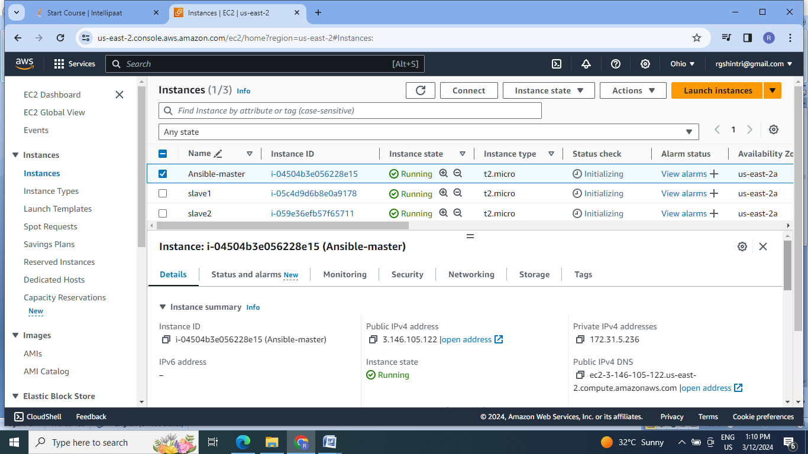

2.Install Ansible on master machine, create the cluster of 3 nodes .

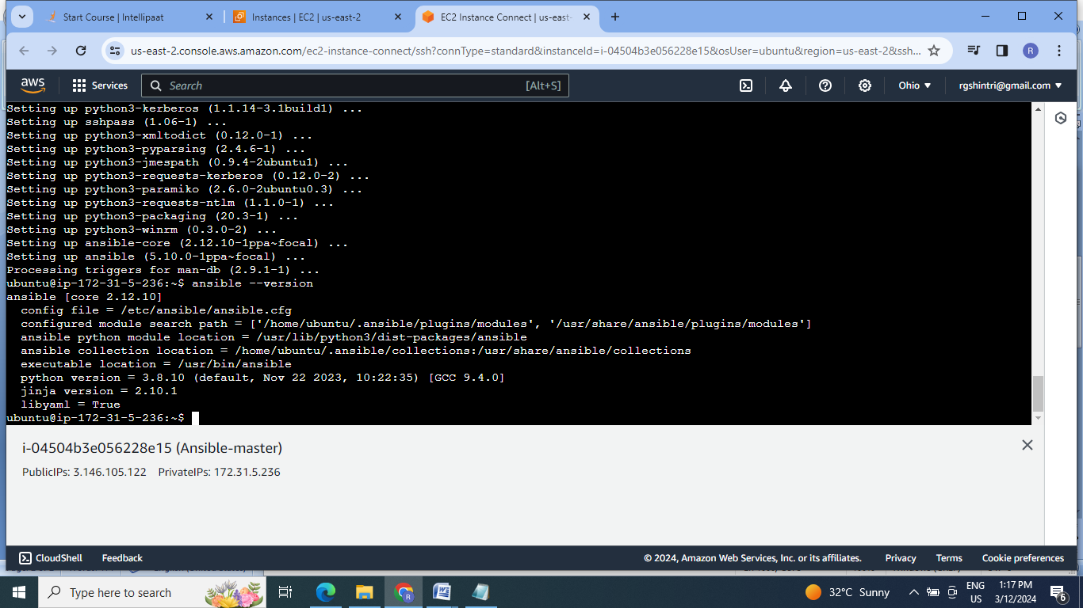

3. Create the keys for cluster formation,copy this keys to both slaves authorized _keys:

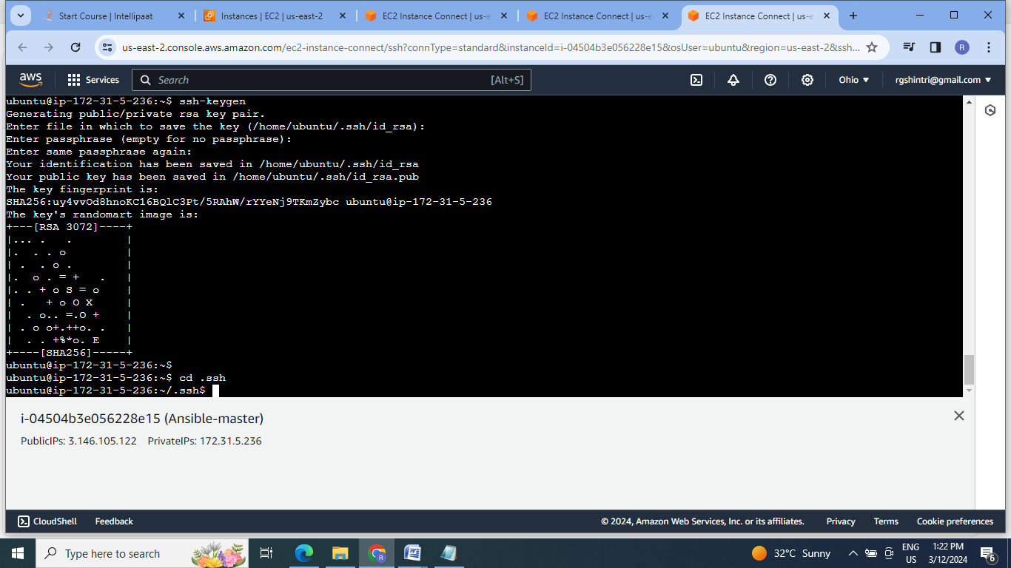

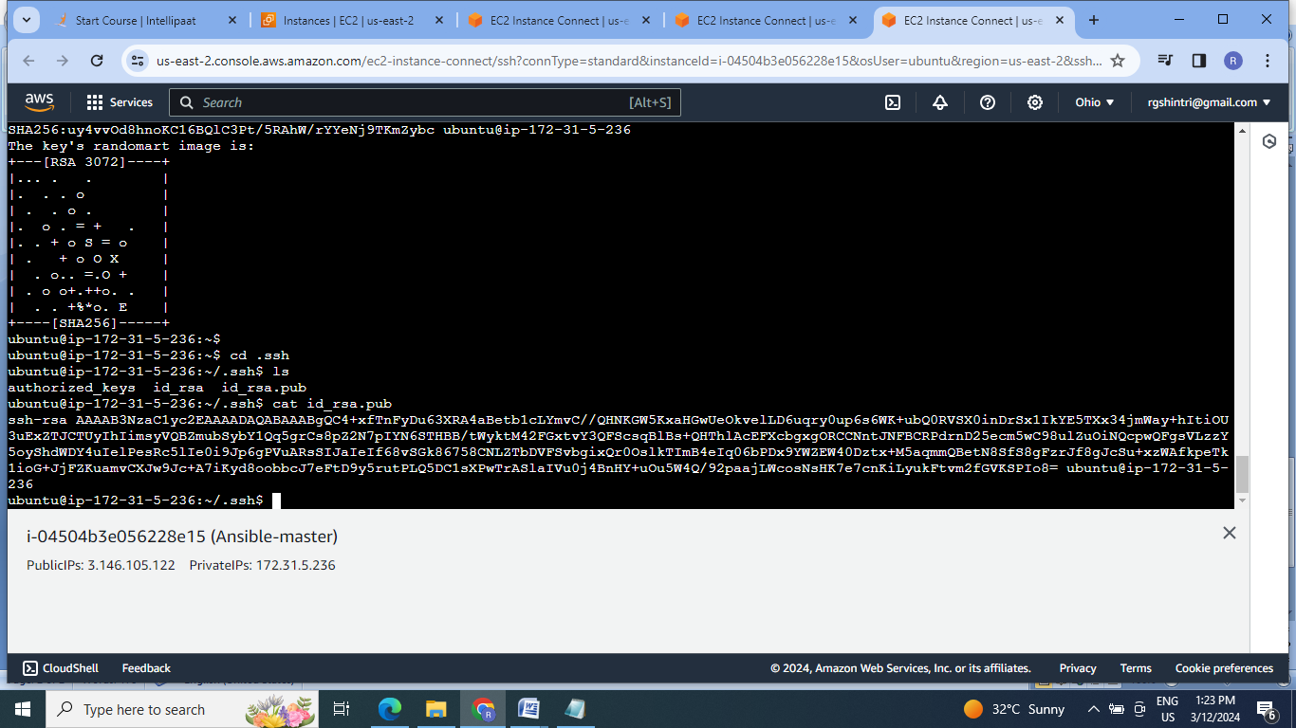

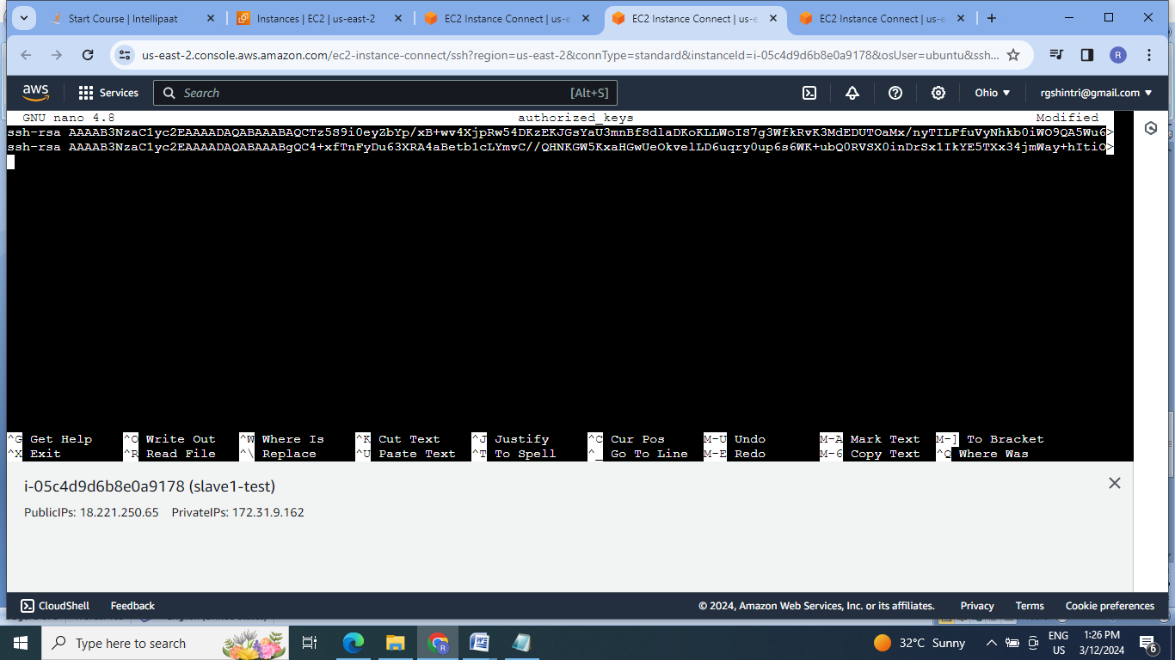

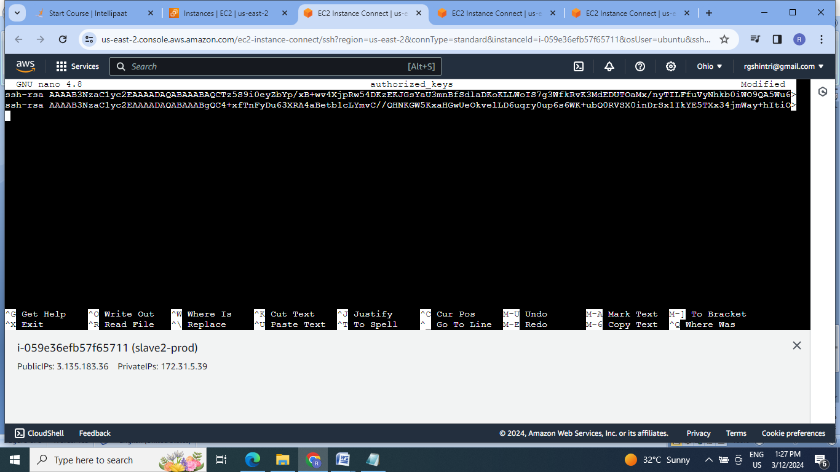

4.Enroll the slave machines under the hosts file of ansible :

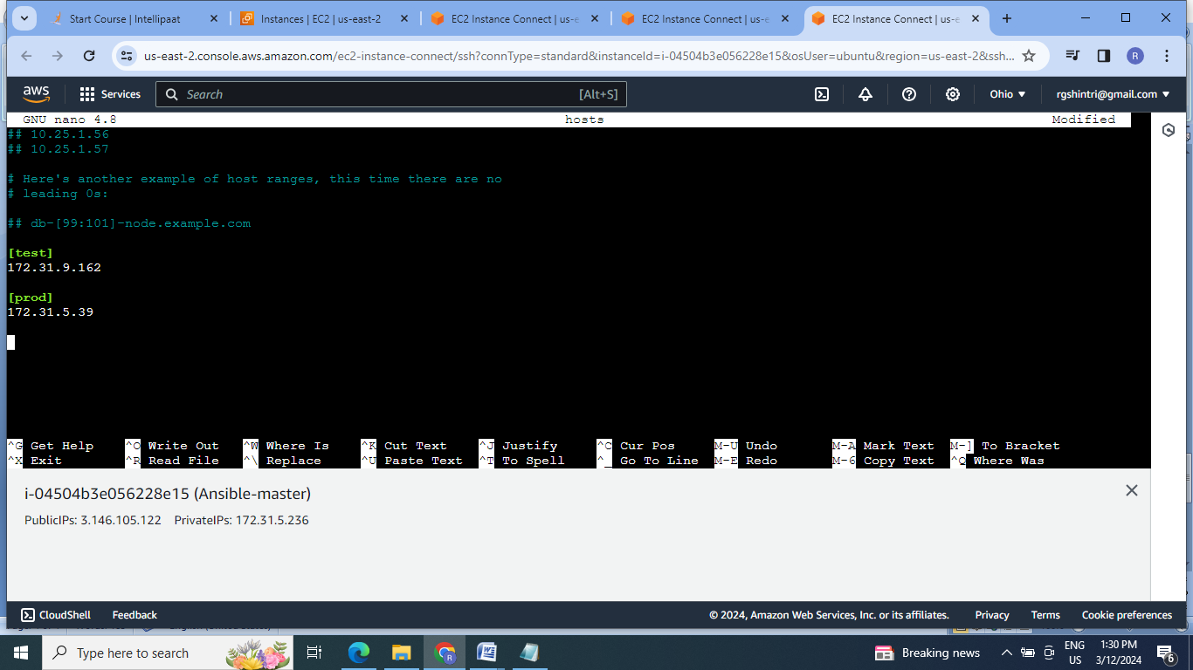

5.Check for cluster formation:

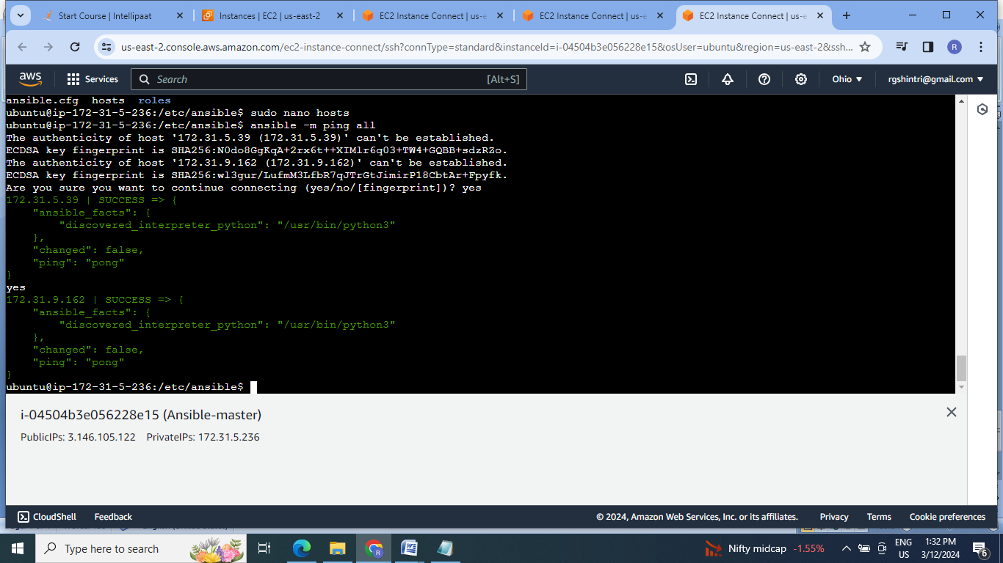

6.Install java, Jenkins & docker on master & java ,docker on slave machines using ansible playbook:

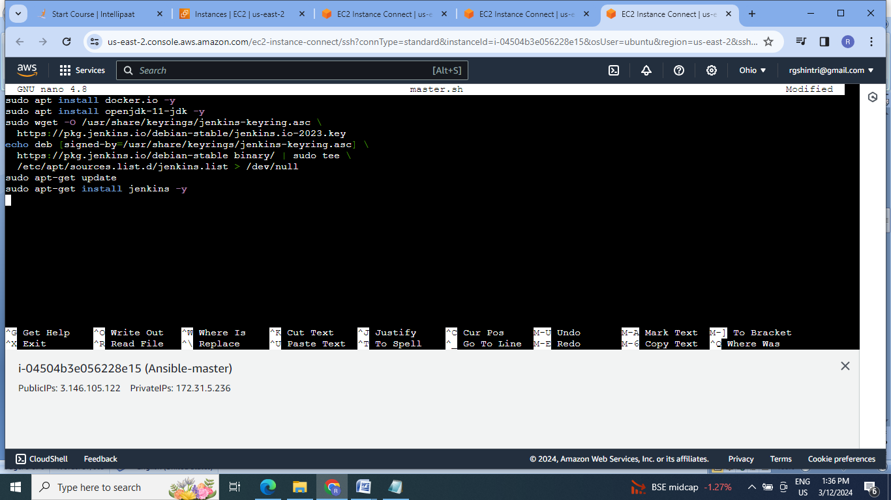

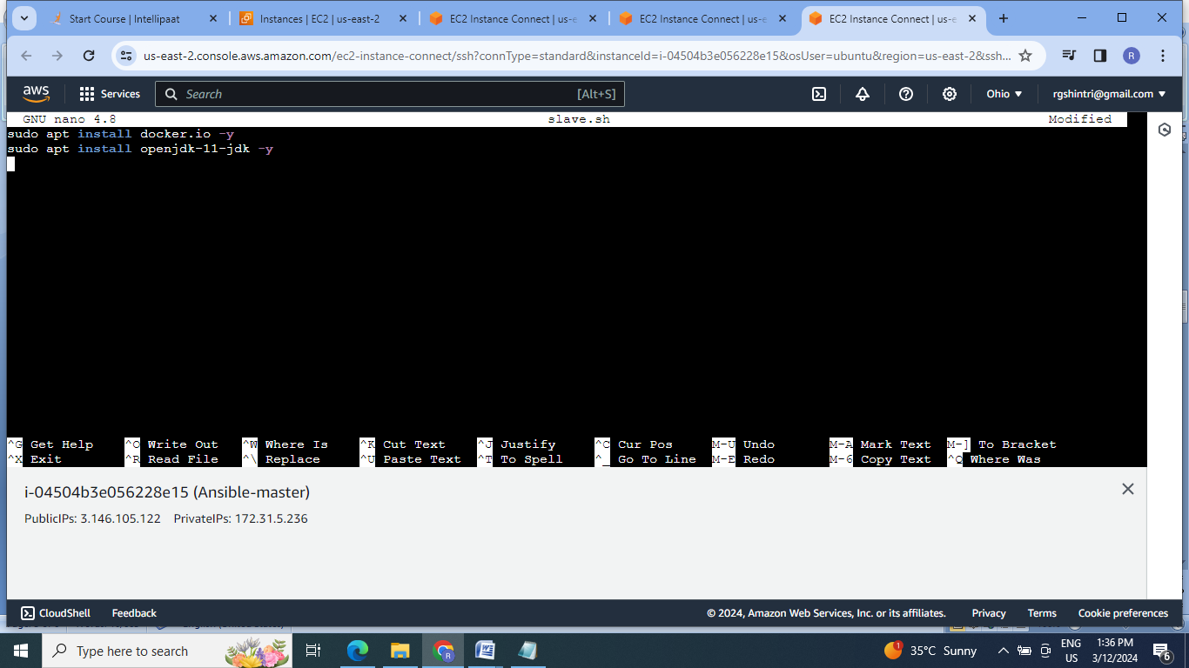

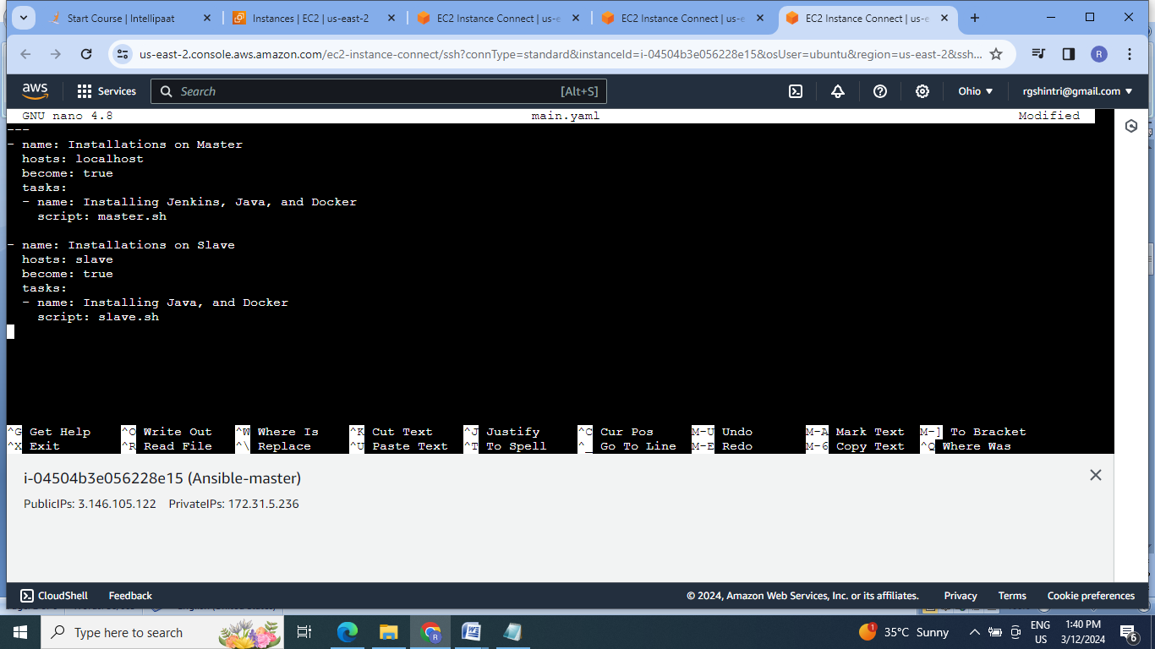

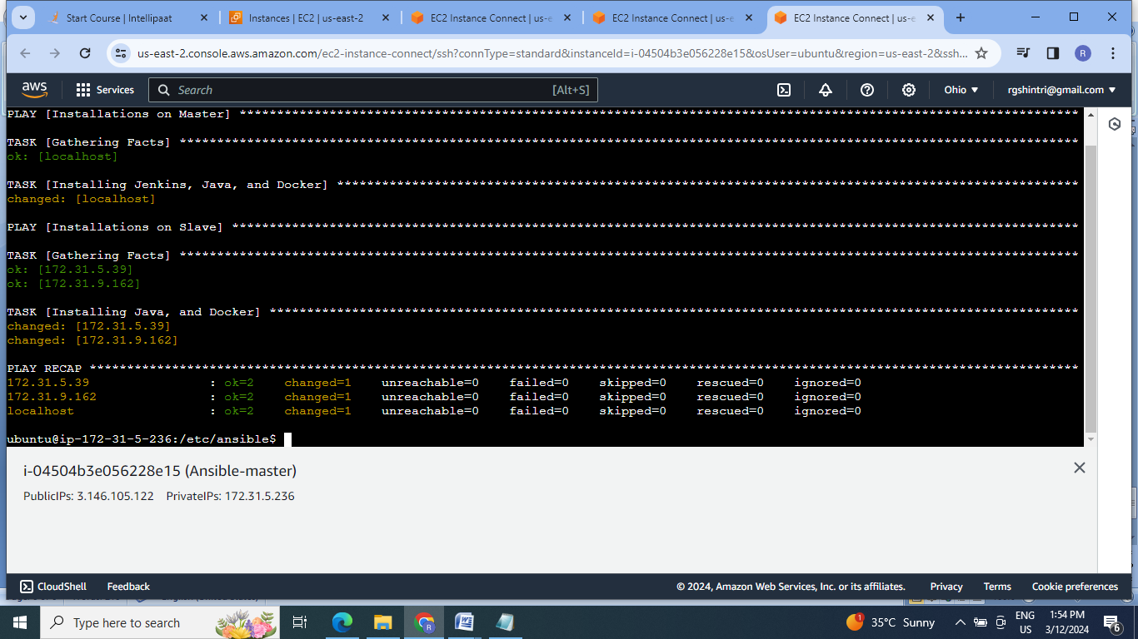

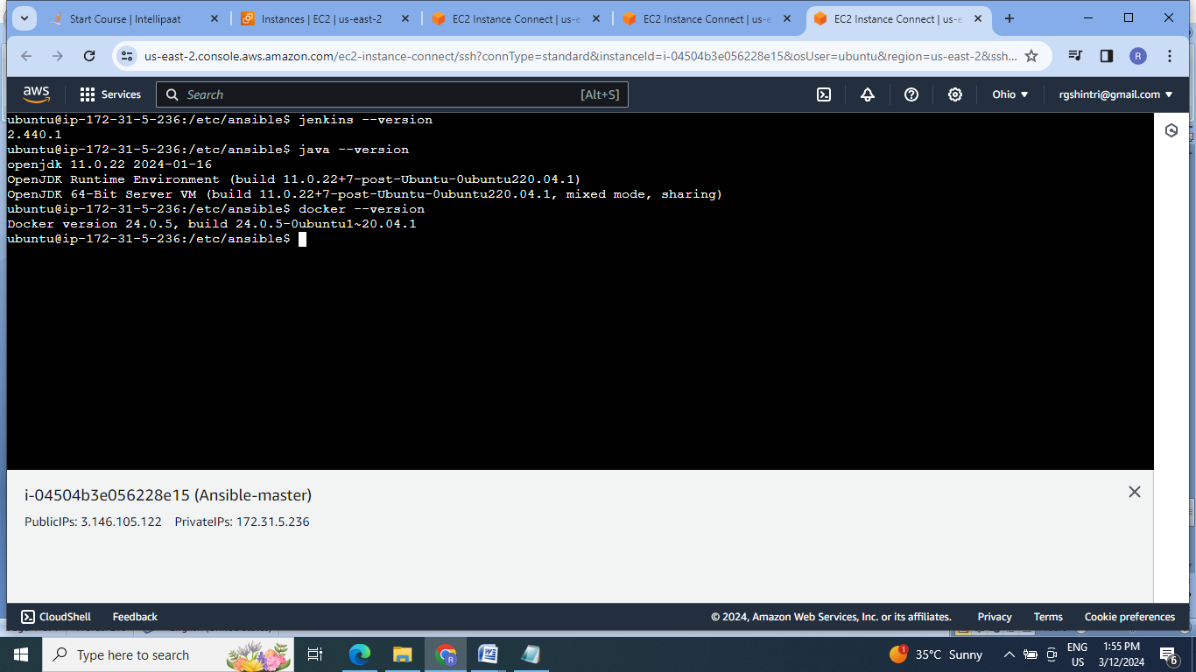

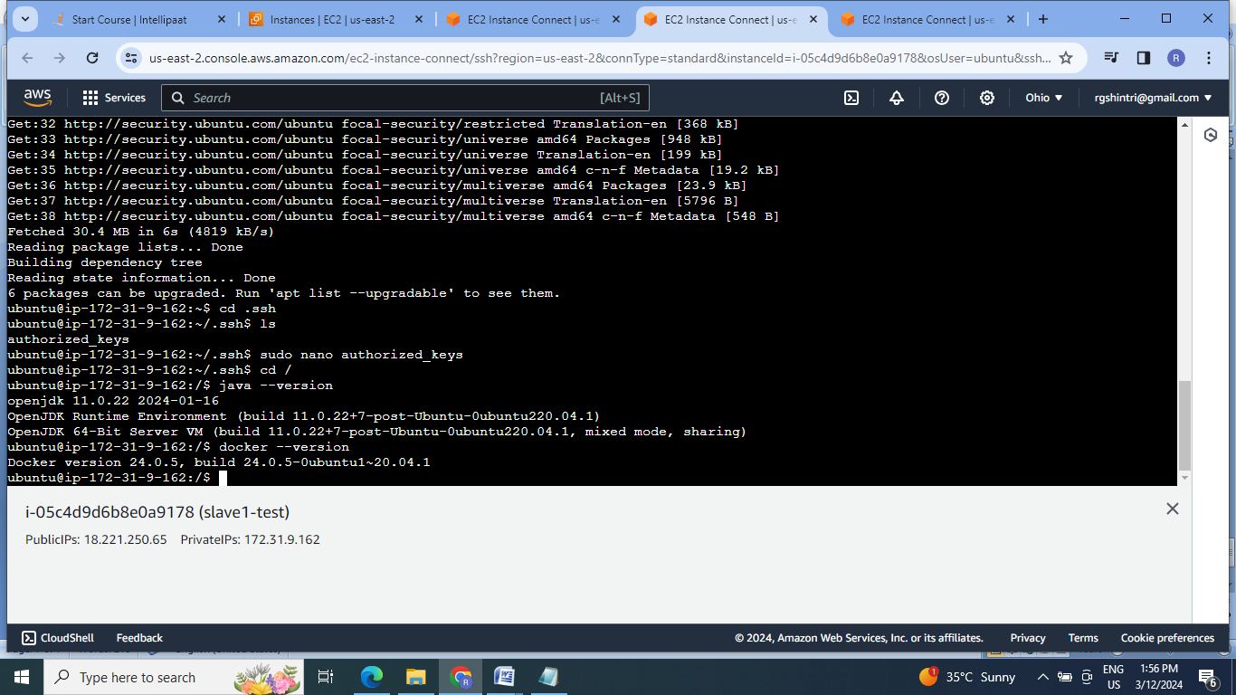

7. Set up Jenkins dashboard & login:

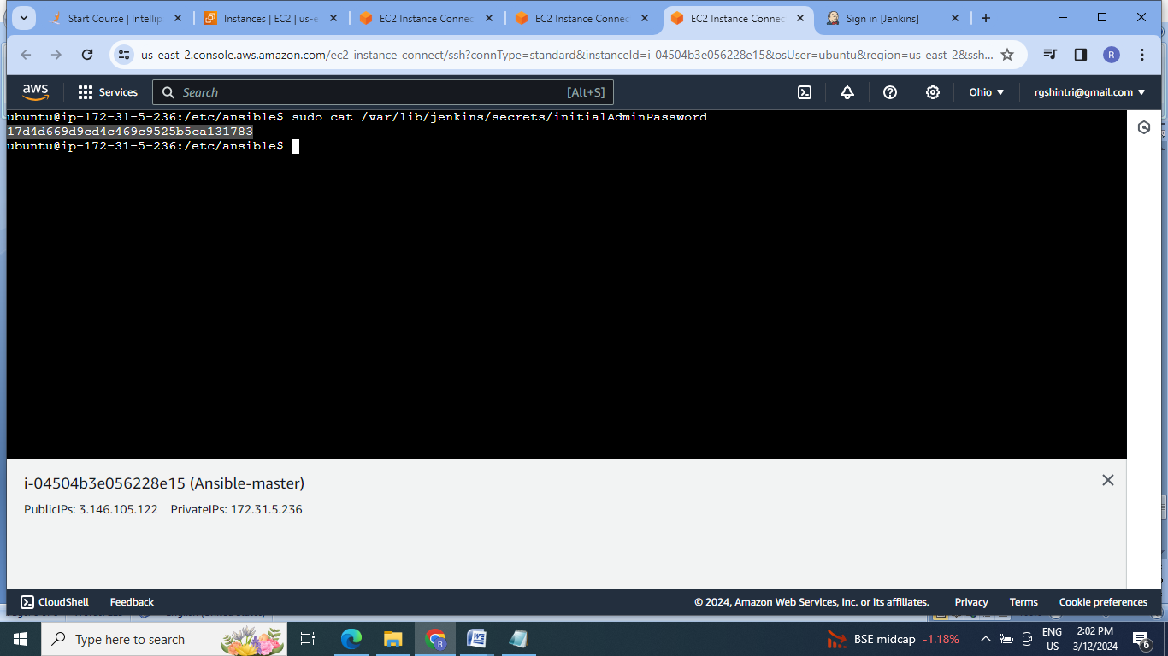

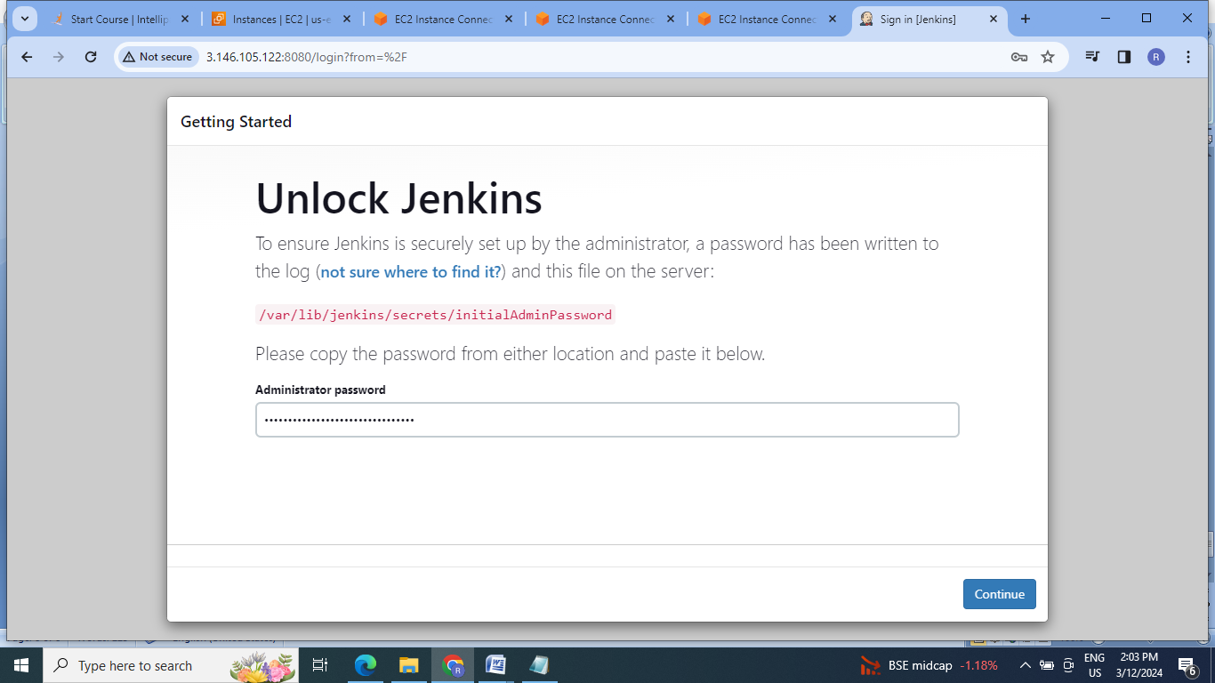

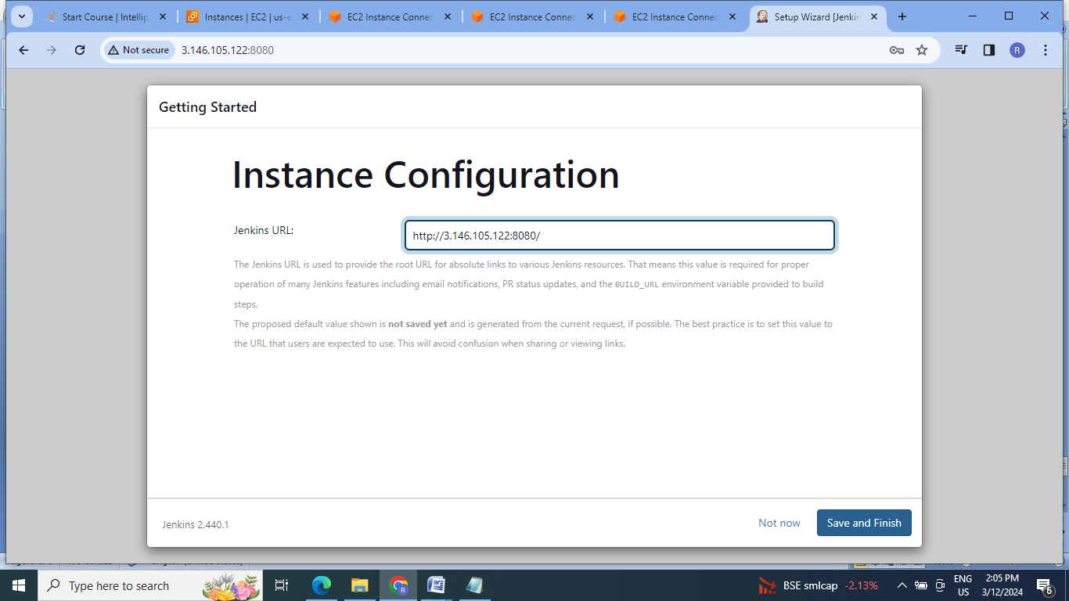

8.Configure the slave machines as test & prod nodes :

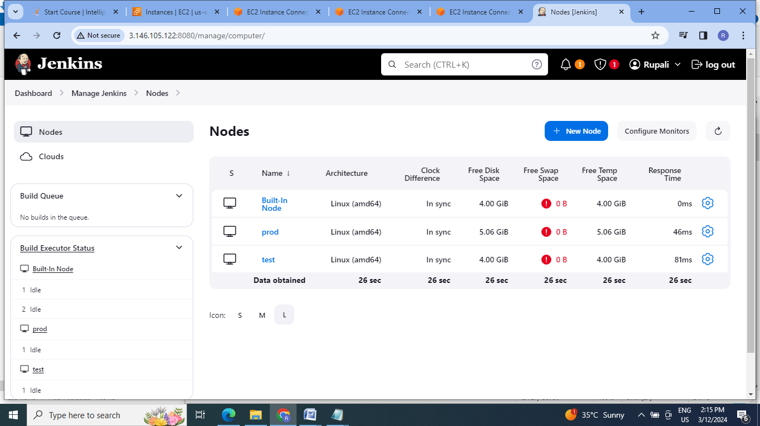

9.Fork the given gitHub repo in our github account:

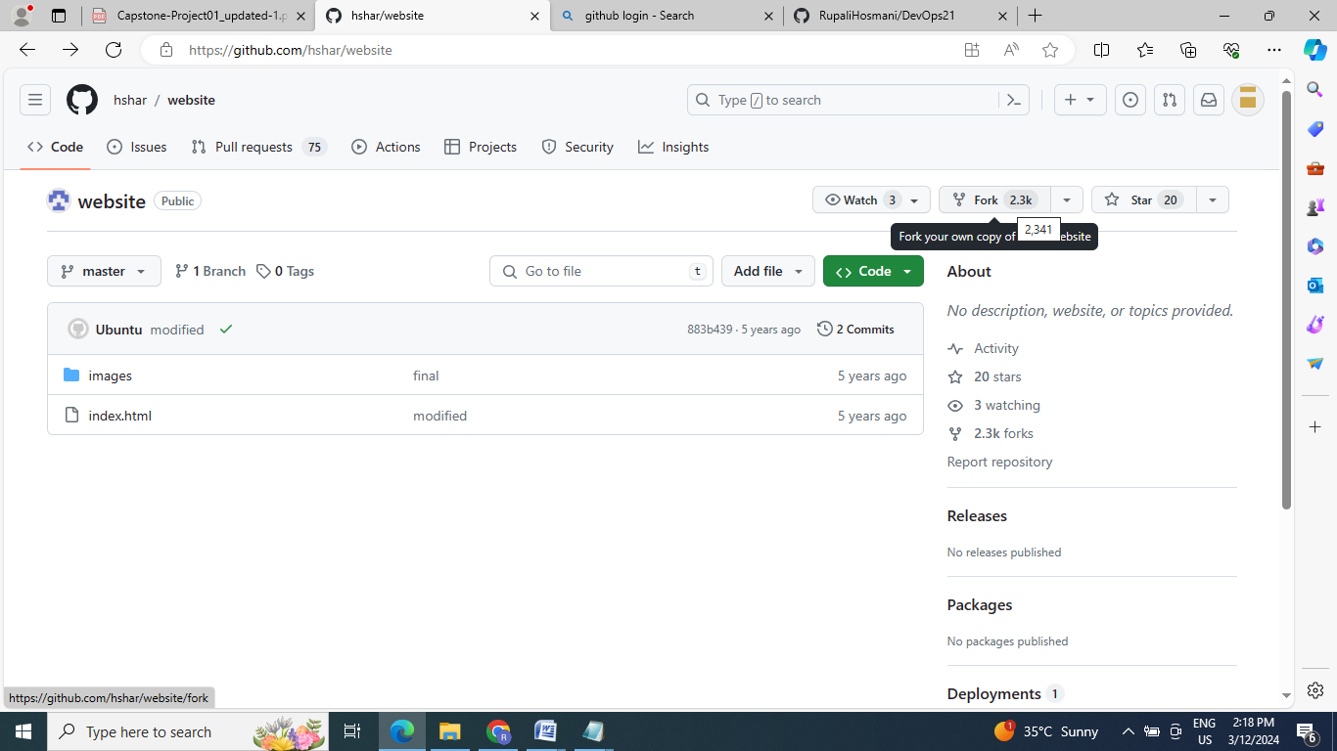

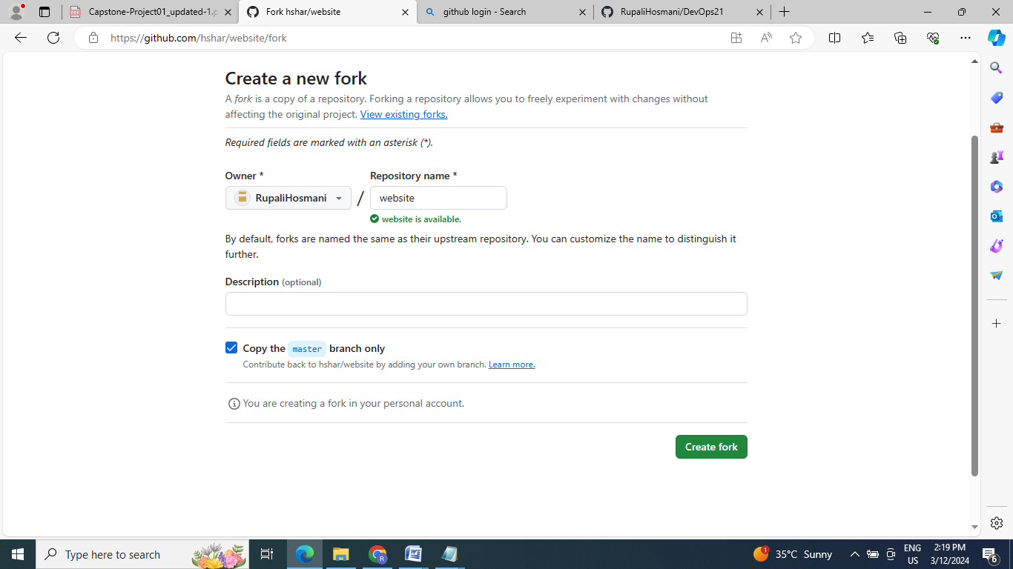

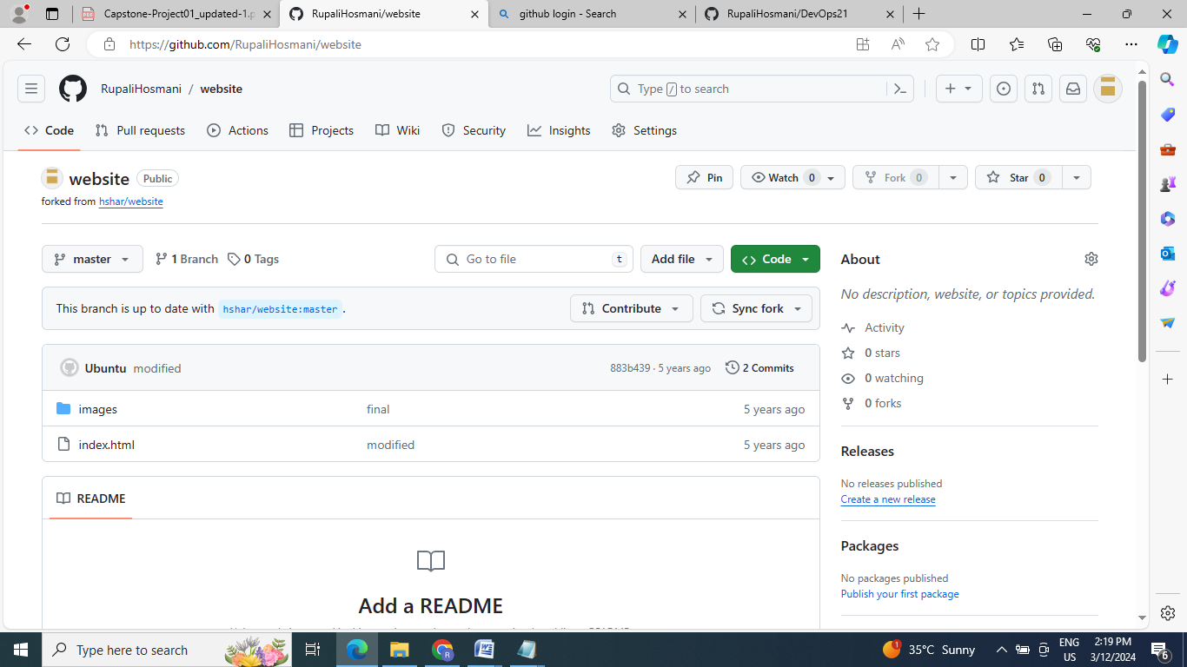

10. Clone the github repository on master machine:

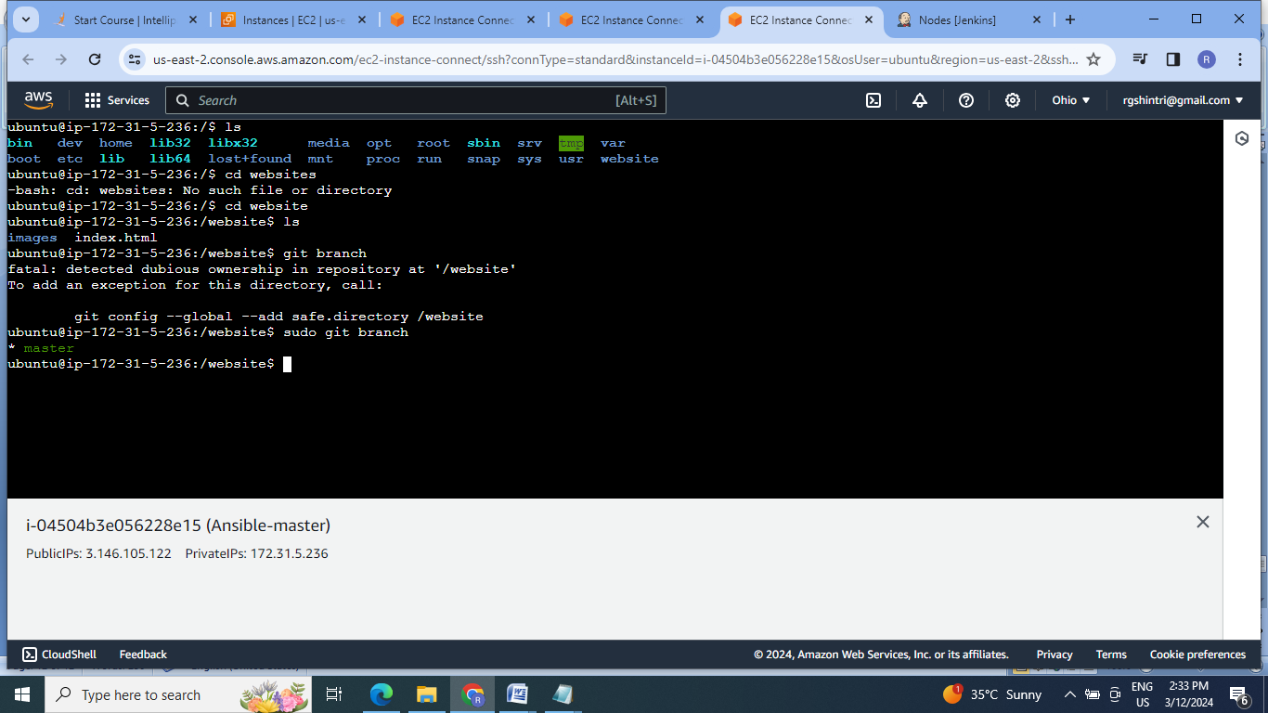

11. Create a Docker file to create image of “images” & index.html files,add & commit the same:

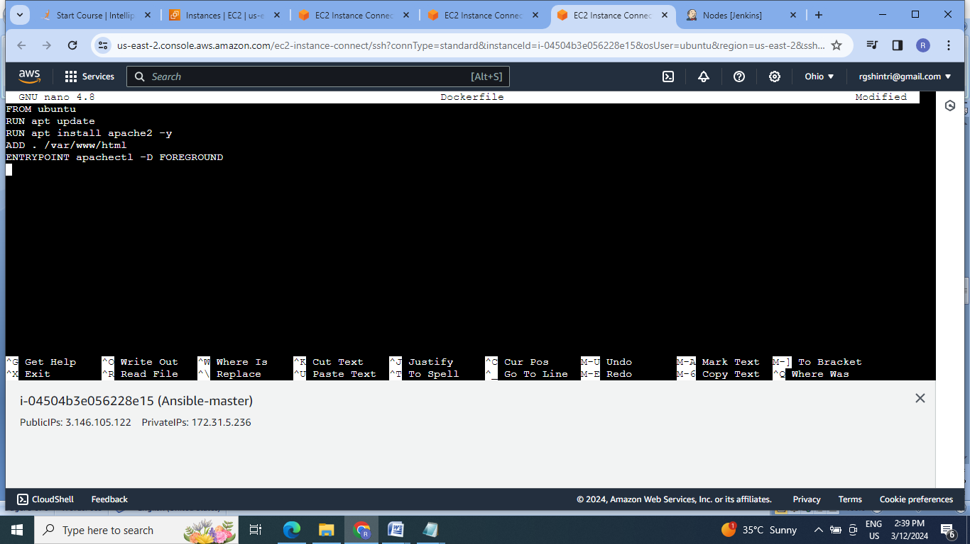

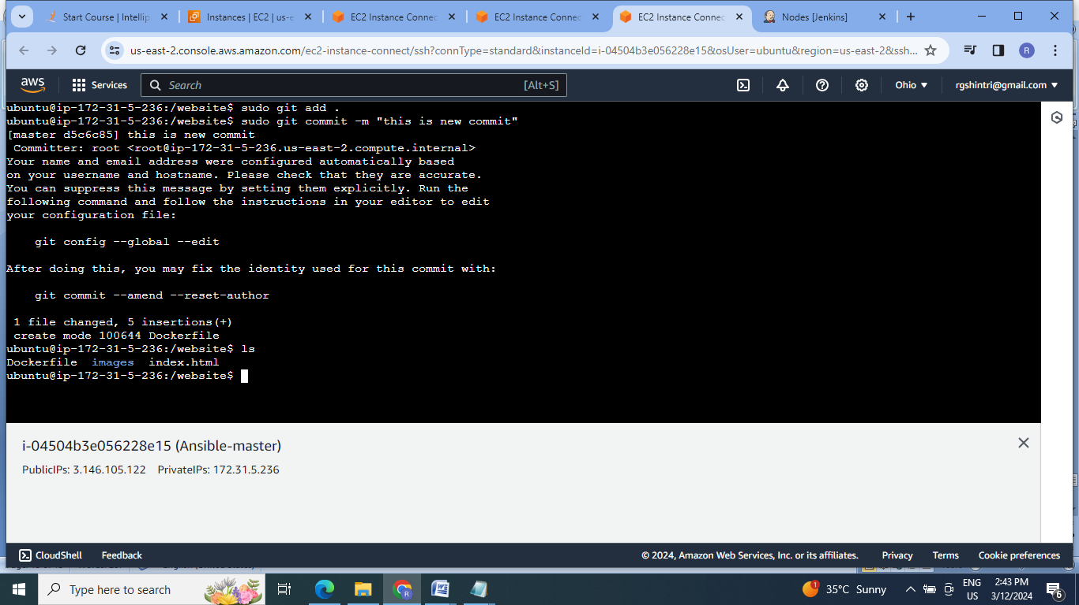

12.Craete the new develop branch:

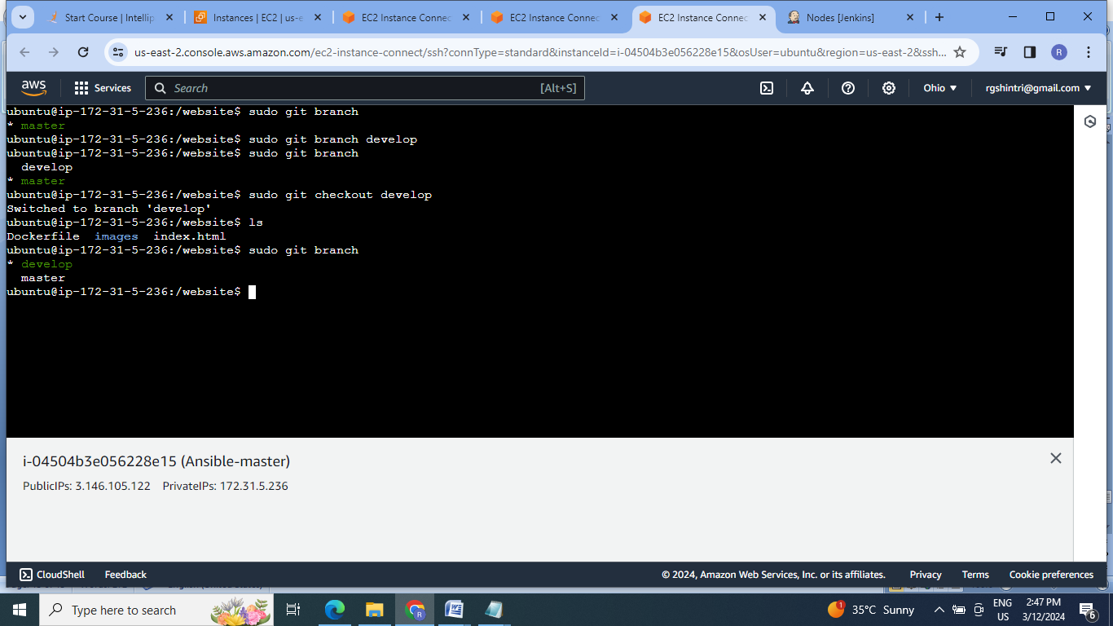

13. Now create job1 in Jenkins by adding webhook for If commit is made to develop branch, just test the product, do not push to prod.

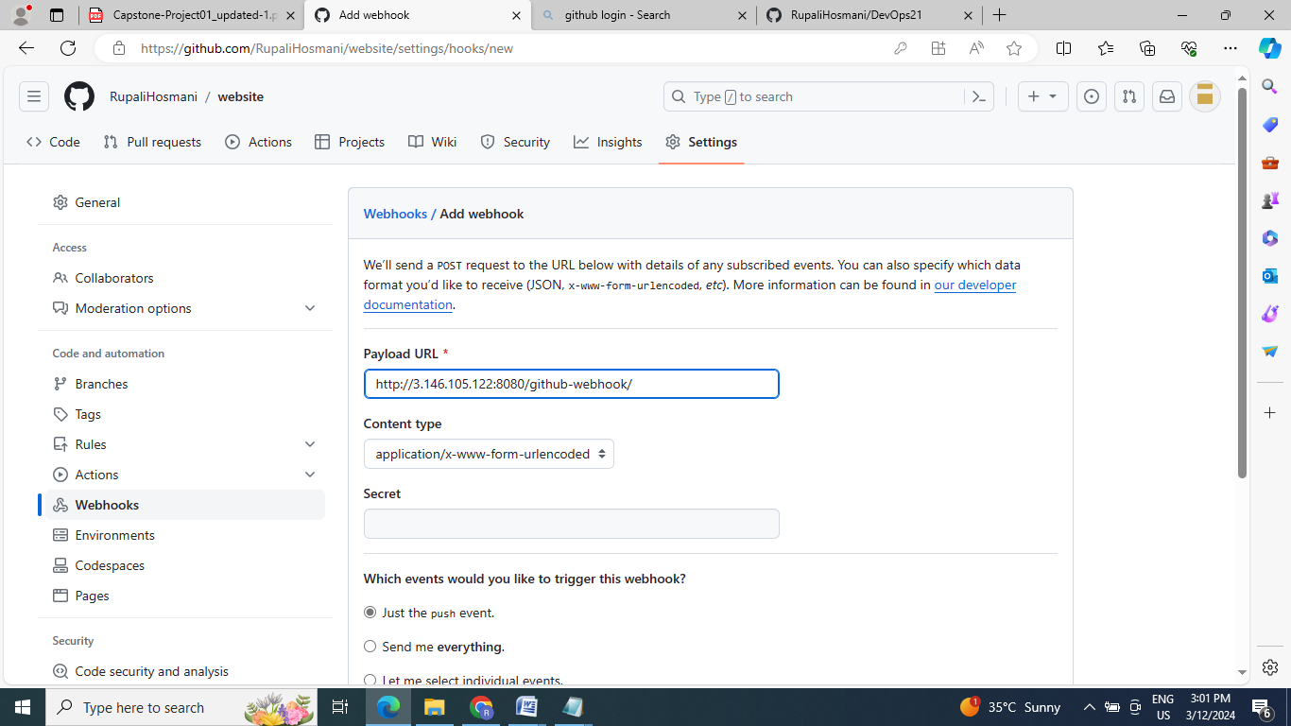

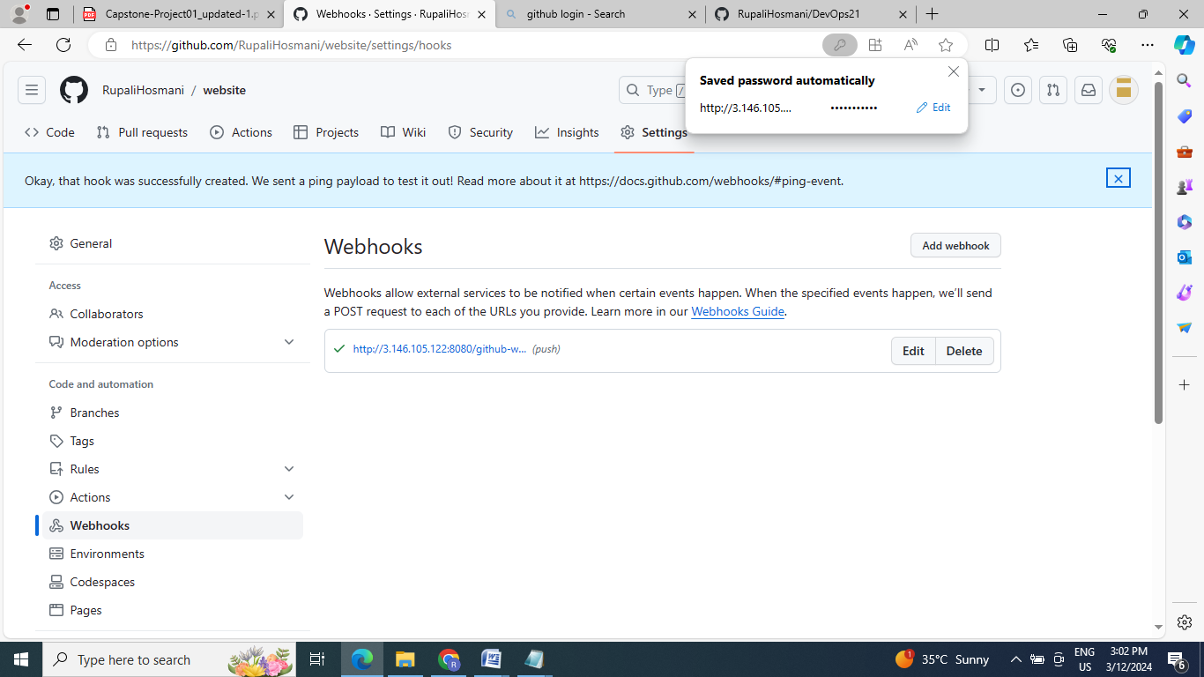

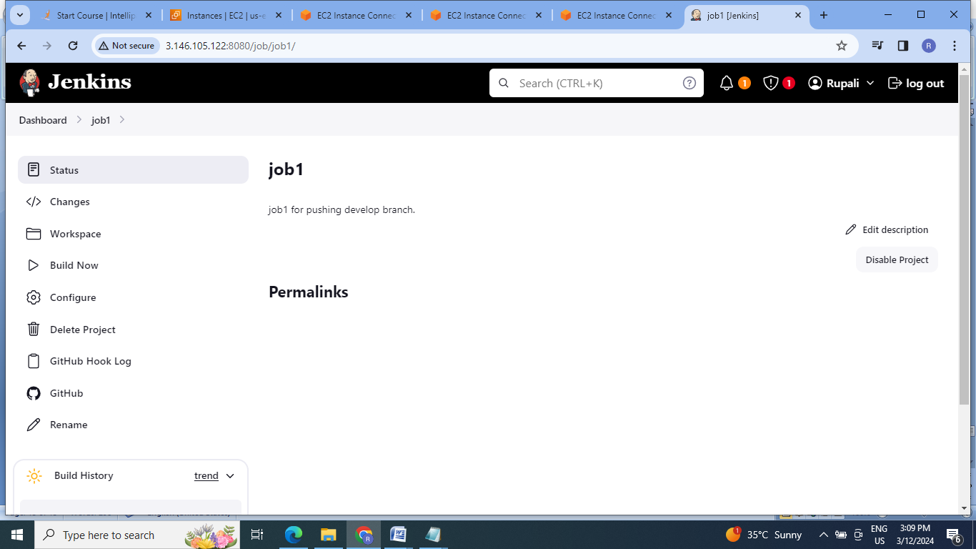

14. Push the develop branch ,generate the token for password & check the job1 status:

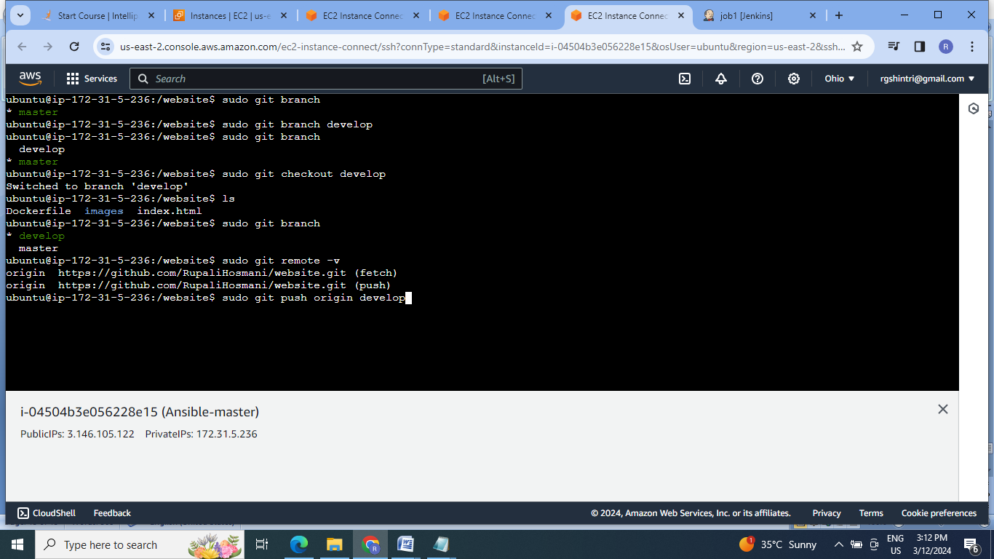

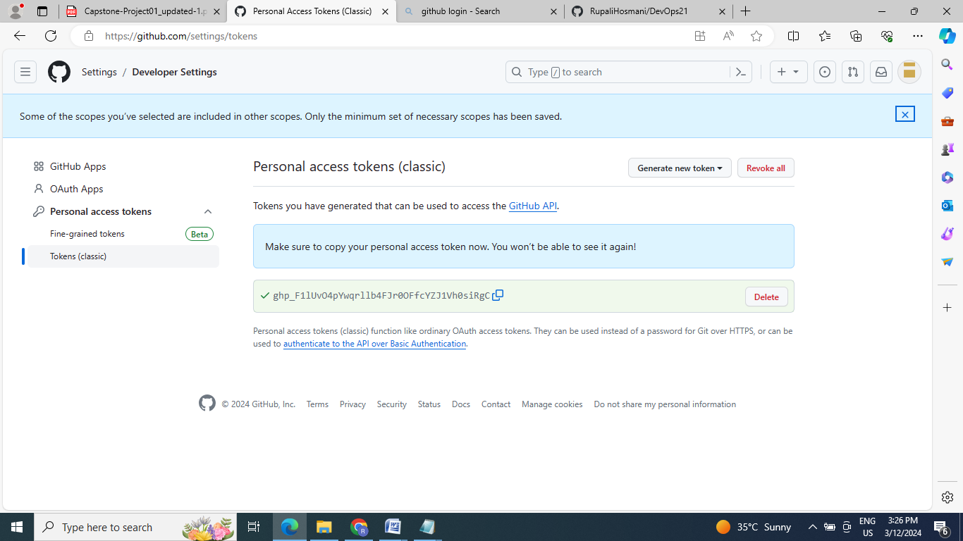

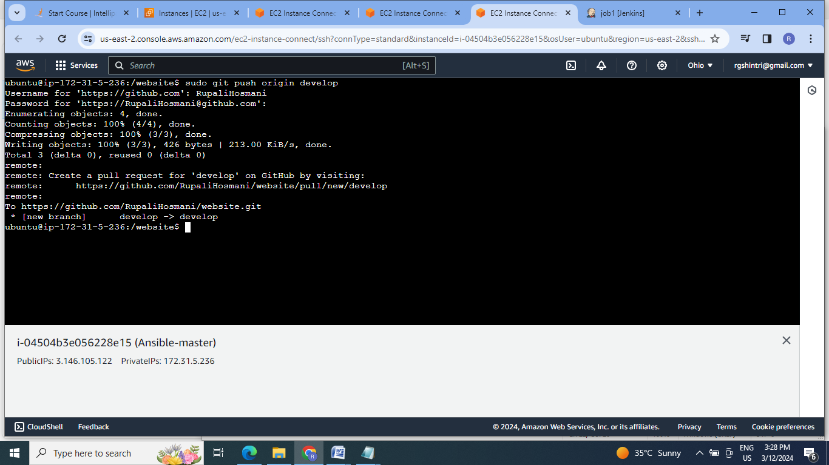

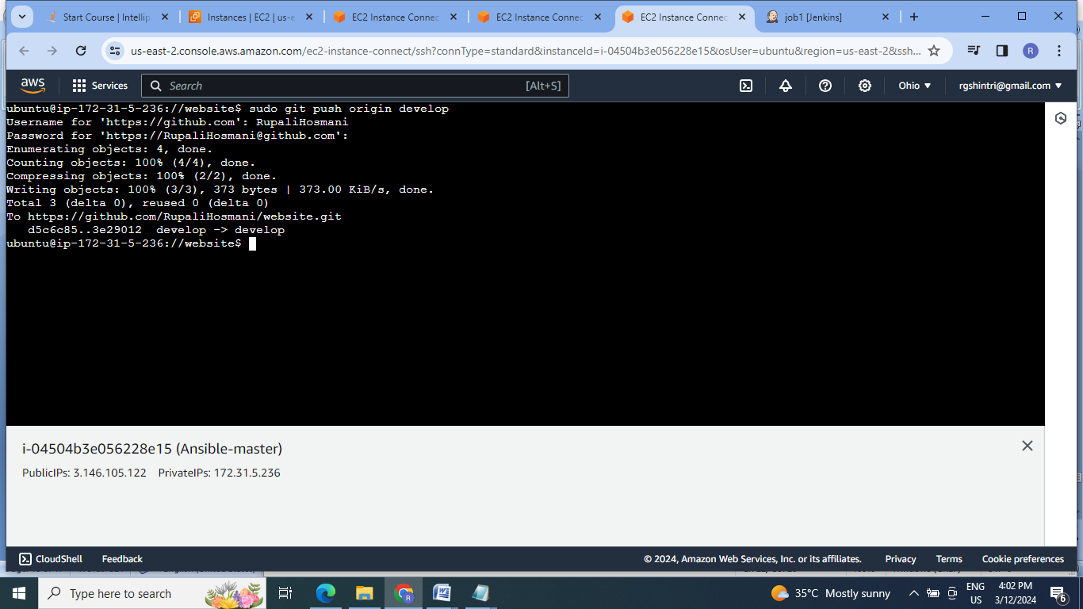

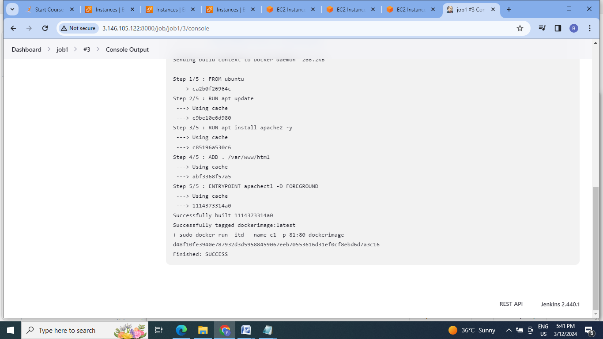

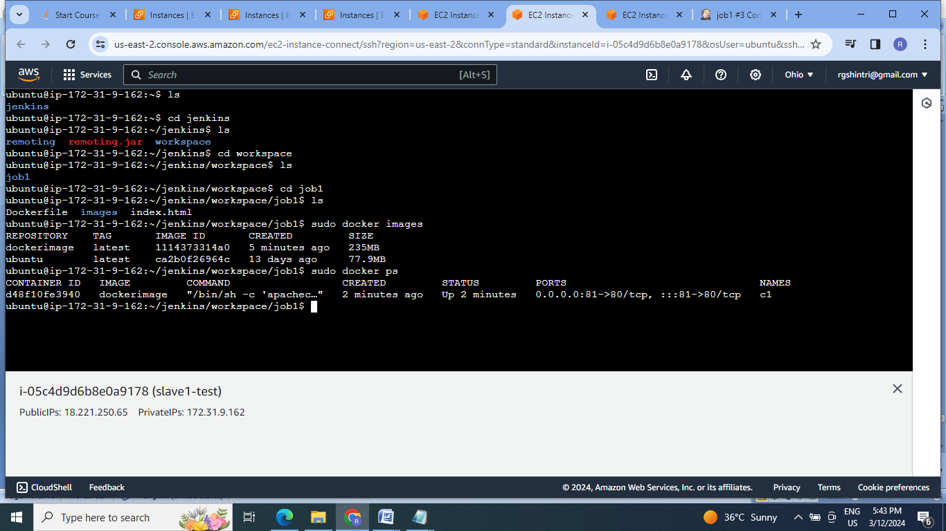

15. Check the application running on test slave ip at port81:

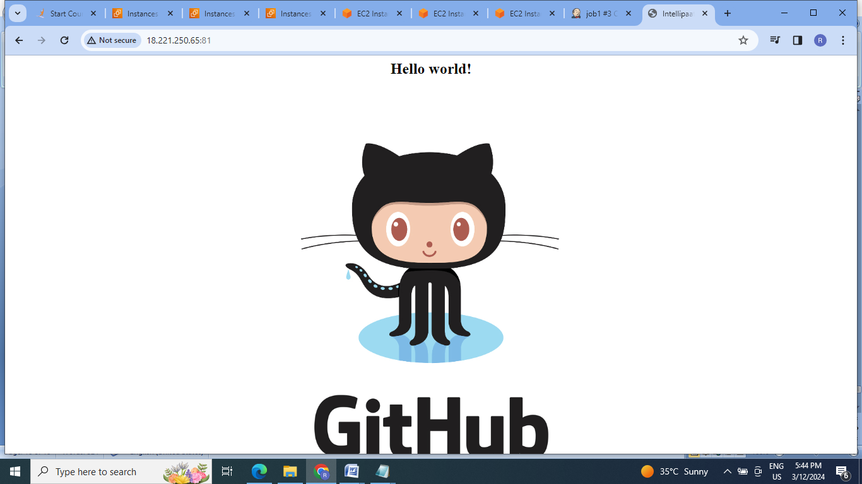

16.Create job 2 for pushing master branch ,test it at port 82:

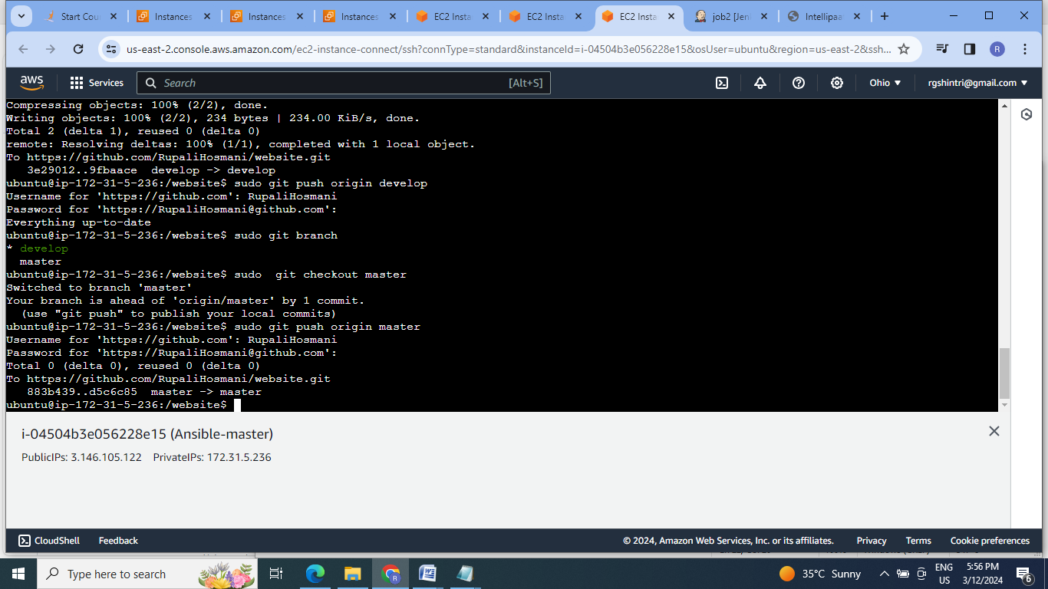

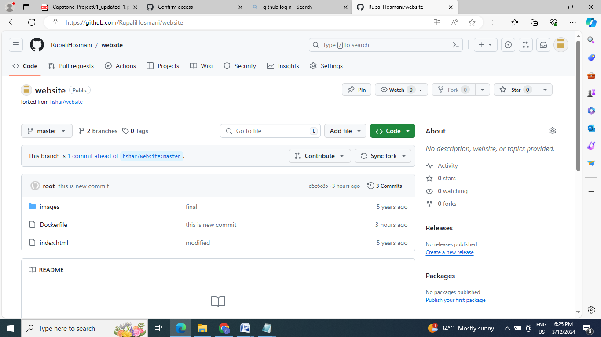

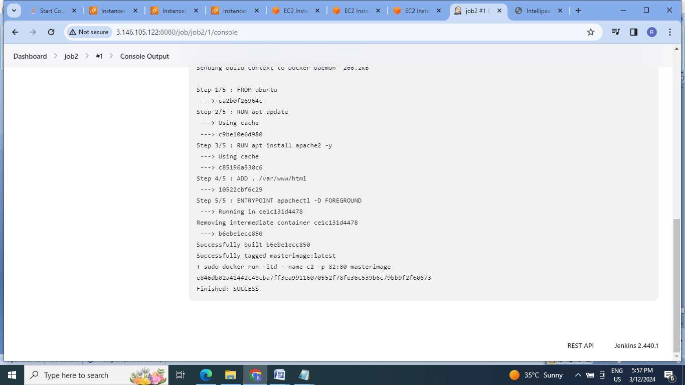

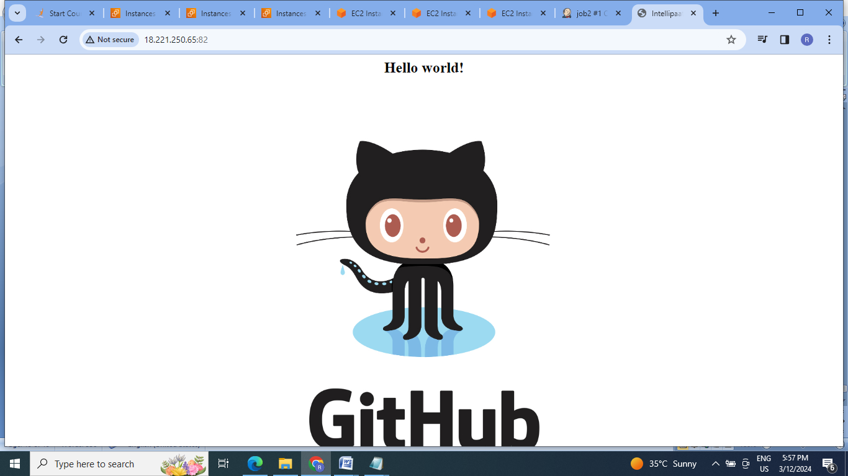

17.Create job3 for hosting the application on port 80 , for master push which should trigger the job2 & job2 should trigger job3 if it is successful & host it on prod slave:

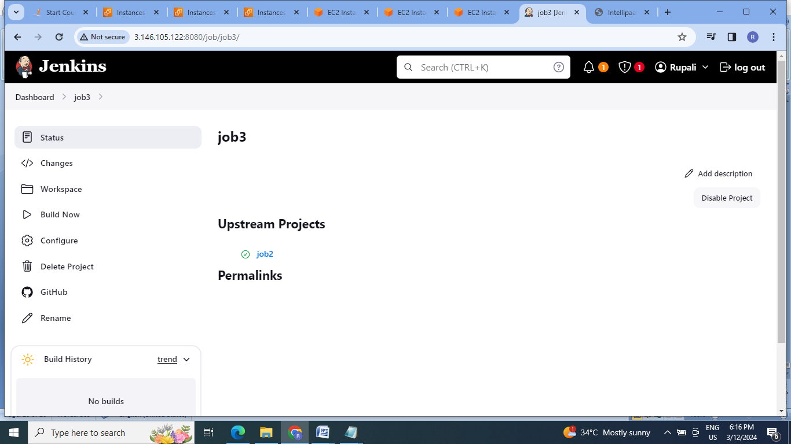

18. Check for the job3:

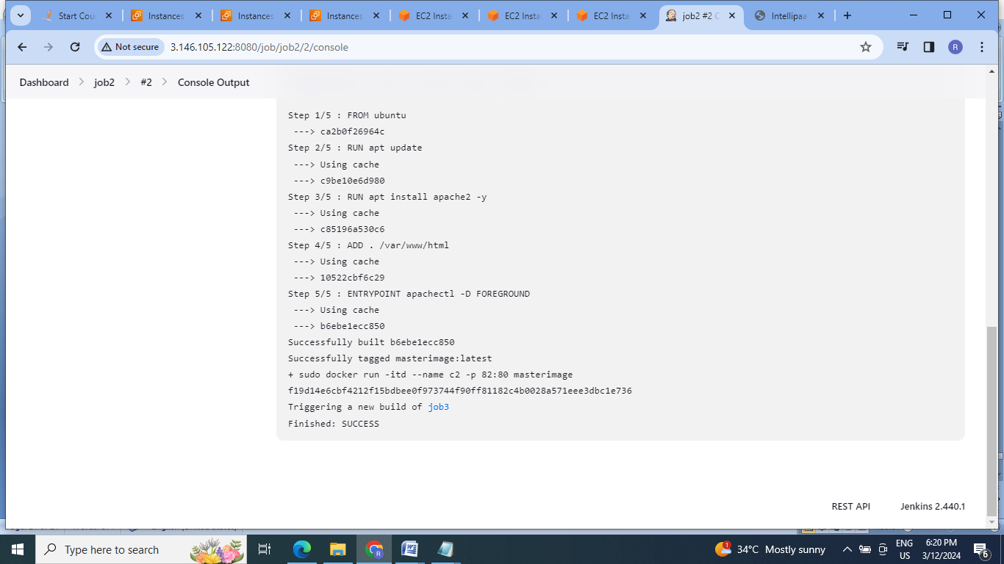

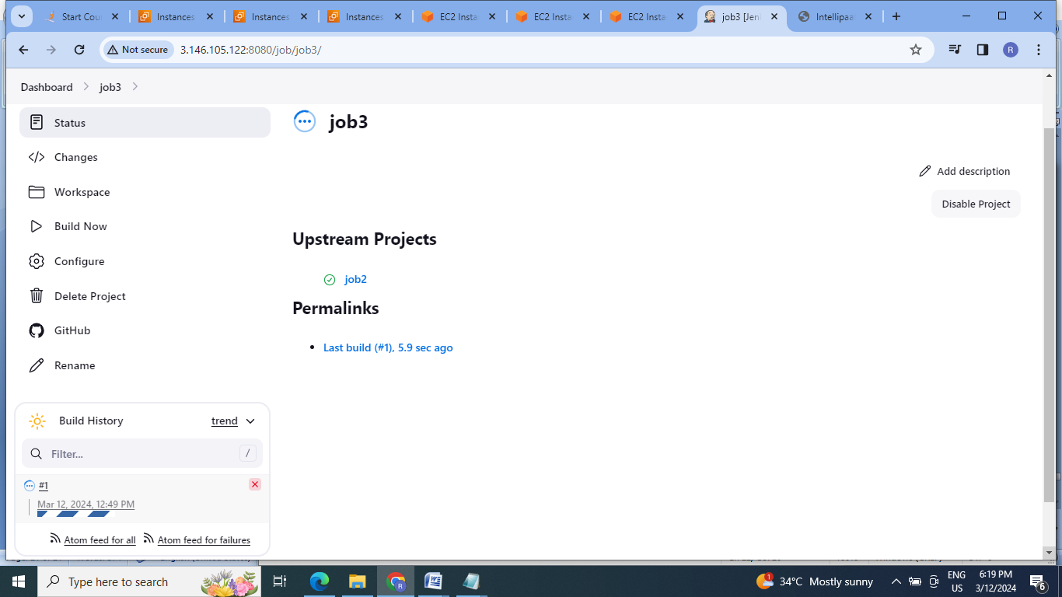

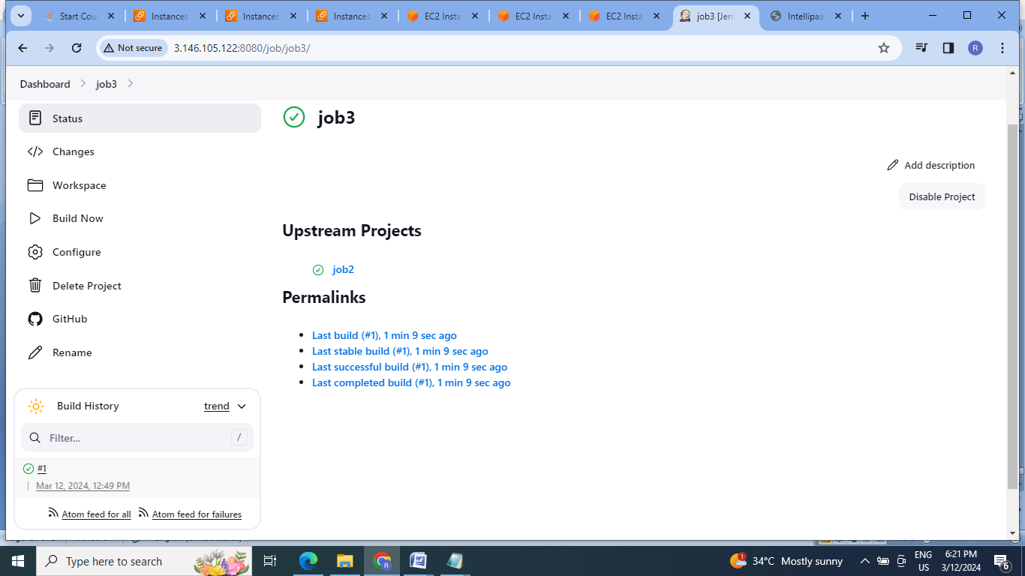

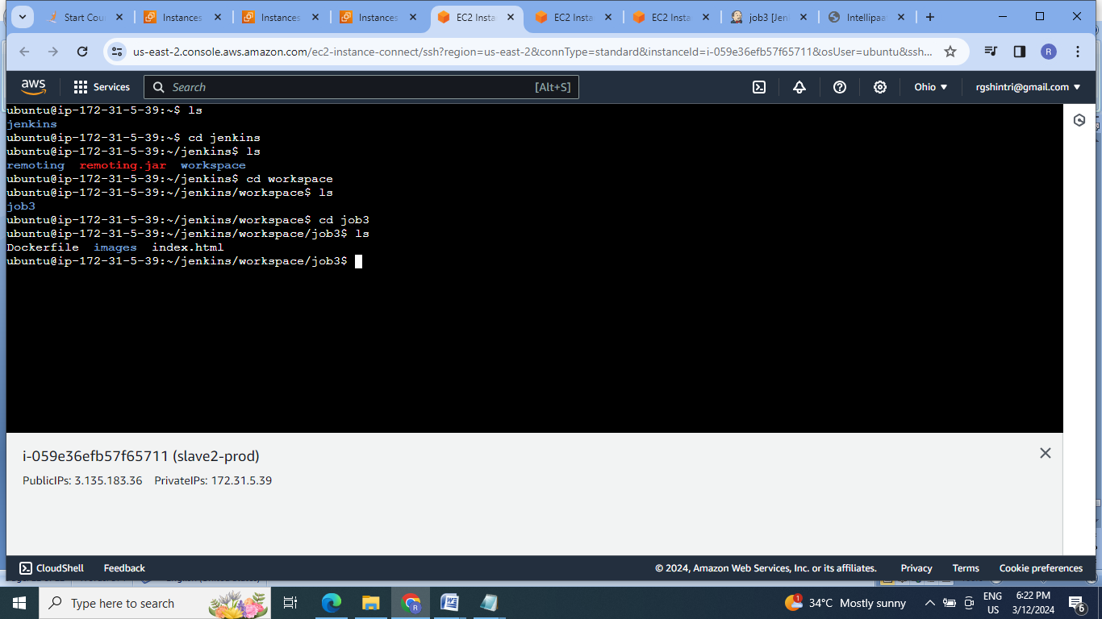

19.Check final application on IP of prod slave:

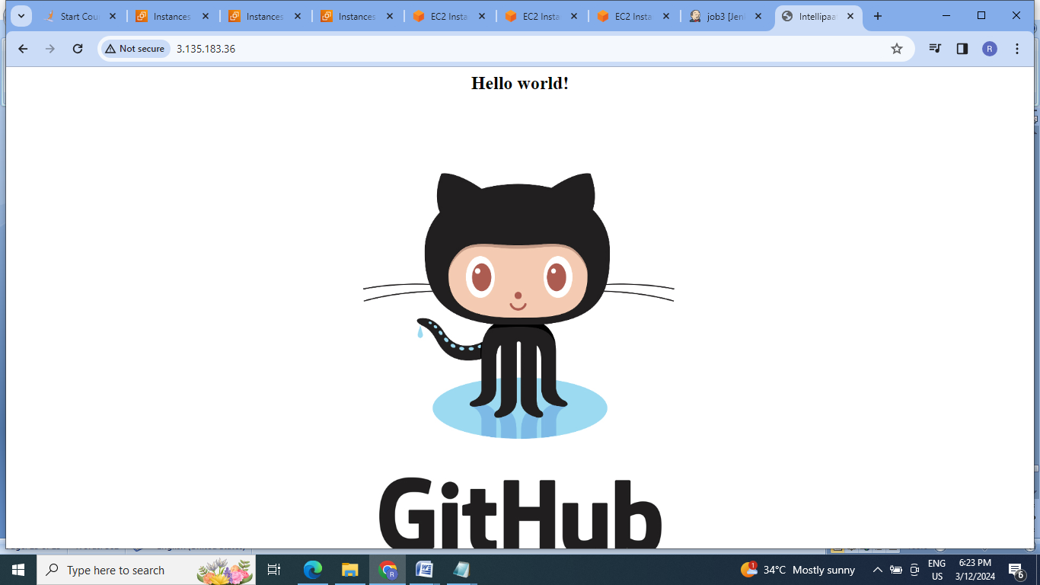

**Conclusion :** So here in this project used ansible as configuration management tool for installation of various software on master & slave machines. Docker is used for containerizing the application & then using Jenkins continuous integration & continuous deployment is achieved.

